Tools for Machine Learning:

# Generative Adversarial Networks (2014)

You know that idea of simplicity in network architecture that we just talked about? Well, Google kind of threw that out the window with the introduction of the Inception module. GoogLeNet is a 22 layer CNN and was the winner of ILSVRC 2014 with a top 5 error rate of 6.7%. To my knowledge, this was one of the first CNN architectures that really strayed from the general approach of simply stacking conv and pooling layers on top of each other in a sequential structure. The authors of the paper also emphasized that this new model places notable consideration on memory and power usage (Important note that I sometimes forget too: Stacking all of these layers and adding huge numbers of filters has a computational and memory cost, as well as an increased chance of overfitting).



**Inception Module**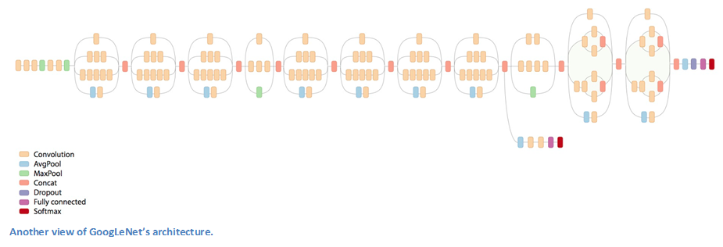

When we first take a look at the structure of GoogLeNet, we notice immediately that not everything is happening sequentially, as seen in previous architectures. We have pieces of the network that are happening in parallel.

This box is called an Inception module. Let’s take a closer look at what it’s made of.

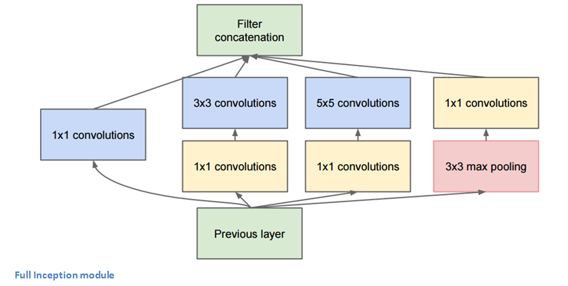

The bottom green box is our input and the top one is the output of the model (Turning this picture right 90 degrees would let you visualize the model in relation to the last picture which shows the full network). Basically, at each layer of a traditional ConvNet, you have to make a choice of whether to have a pooling operation or a conv operation (there is also the choice of filter size). What an Inception module allows you to do is perform all of these operations in parallel. In fact, this was exactly the “naïve” idea that the authors came up with.

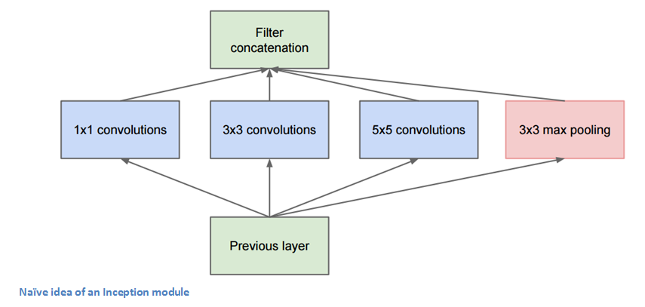

Now, why doesn’t this work? It would lead to **way** too many outputs. We would end up with an extremely large depth channel for the output volume. The way that the authors address this is by adding 1x1 conv operations before the 3x3 and 5x5 layers. The 1x1 convolutions (or network in network layer) provide a method of dimensionality reduction. For example, let’s say you had an input volume of 100x100x60 (This isn’t necessarily the dimensions of the image, just the input to any layer of the network). Applying 20 filters of 1x1 convolution would allow you to reduce the volume to 100x100x20. This means that the 3x3 and 5x5 convolutions won’t have as large of a volume to deal with. This can be thought of as a “pooling of features” because we are reducing the depth of the volume, similar to how we reduce the dimensions of height and width with normal maxpooling layers. Another note is that these 1x1 conv layers are followed by ReLU units which definitely can’t hurt (See Aaditya Prakash’s [great post](http://iamaaditya.github.io/2016/03/one-by-one-convolution/) for more info on the effectiveness of 1x1 convolutions). Check out this [video](https://www.youtube.com/watch?v=VxhSouuSZDY) for a great visualization of the filter concatenation at the end.

You may be asking yourself “How does this architecture help?”. Well, you have a module that consists of a network in network layer, a medium sized filter convolution, a large sized filter convolution, and a pooling operation. The network in network conv is able to extract information about the very fine grain details in the volume, while the 5x5 filter is able to cover a large receptive field of the input, and thus able to extract its information as well. You also have a pooling operation that helps to reduce spatial sizes and combat overfitting. On top of all of that, you have ReLUs after each conv layer, which help improve the nonlinearity of the network. Basically, the network is able to perform the functions of these different operations while still remaining computationally considerate. The paper does also give more of a high level reasoning that involves topics like sparsity and dense connections (read Sections 3 and 4 of the [paper](http://www.cv-foundation.org/openaccess/content_cvpr_2015/papers/Szegedy_Going_Deeper_With_2015_CVPR_paper.pdf). Still not totally clear to me, but if anybody has any insights, I’d love to hear them in the comments!).

